**Research Proposal**

|  |  |  |
| --- | --- | --- |
|  | **NAME OF RESEARCH STUDENT:** | Kapase Ajay Babasaheb |
|  | **TITLE OF PROPOSED RESEARCH: WORK** | Multi-Attribute Based  Artificial Emotional Intelligent  Affective Systems  for  Cooperative Machine-Human Interaction. |

1. **RESEARCH SUMMARY:**

Over a past few years the term AI gained huge popularity defining a new era of machines carrying the intelligence which will simulate the human intelligence. The AI today is in its very basic stage. However there are three stages of AI defined as follows:

* Artificial narrow intelligence (ANI)[2]
* Artificial general intelligence (AGI) [2]
* Artificial super intelligence (ASI) [2]

Current stage of AI is said to be Artificial Narrow Intelligence [2] and is a very basic stage of where the machines are still far away from actual human intelligence. The later stage of AI is considered as more advanced and called as Artificial General Intelligence where machines will have strong capabilities of complex problem solving and reasoning. The third stage of AI is considered to be a very powerful stage where machine will have ability of decision making and it will surpass the human intelligence and called as a state of intelligence explosion [3] which can be considered as the possibly critical and unsafe stage for humans even AI can give solution to some critical problems.

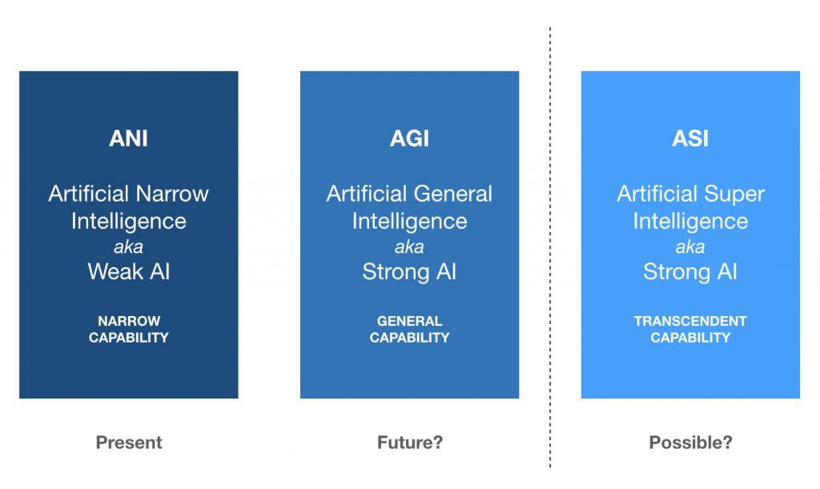

**Fig 1. Three Stages of Artificial Intelligence [3]**

Understanding this scenario machines today rather than being simply Artificially Intelligence they need to be more Emotionally Intelligent machines which will understand, simulate and react to human emotions, making the human-machine interaction and hence relation more strong and cooperative The research aims to simulate the human emotional intelligence in the machines and making it more precise by applying certain physical and psychological behavior patterns in human to human interaction.

1. **INTRODUCTION:**

With introduction of Machine Learning and Artificial intelligence the machines today are striving hard to become intelligent rather than only becoming accurate. The term Artificial Intelligence defines simulation of human intelligence by the machines. This intelligence can be improved automatically over the time as machine goes on learning. As far as AI is concerned we have various robotic systems, softwares like stock market predictions system, even the personal digital assistants like Siri, Google Assistant ans Alexa which helps people making human life easier.

Considering an example of personal digital assistants like Siri, Alexa they are most intelligent as long as answering the questions and doing online tasks are concerned but can be considered as dumbest when we consider them from the perspective of emotional intelligence. Rosalind Piccard, Director of Affective Computing Research at the MIT once said “Even your dog can understand when you are feeling frustrated of it then why the personal digital assistants cant. Yet developing that kind of intelligence in particular, the ability to recognize human emotions and then respond appropriately is essential to the true success of digital assistants and the many other artificial intelligences (AIs) we interact with every day. So this research will aim for finding out some ways so that machine can be made more emotionally intelligent and connected to humans rather than just being intelligent.

1. **LITERATURE REVIEW:**
   1. **International Status:**

**Artificial (Emotional) Intelligence by Rosalind Picard, *et al.,* (2018)** the word artificial emotional intelligence defined as a part of affective computing where it represents machines can understand and identify human emotions. The literature focused on the drawbacks and limitations of artificial intelligence by giving example of smart assistants like Google assistant, Siri and Alexa these assistants are intelligent enough to provide the accurate answers to asked questions but not smart to identify emotions of human who is asking the questions. Identifies key to improve the result of any smart assistant is to identify the emotion behind every question rather than just answering the question by regular NLP

**Understanding Citizens’ Emotional Pulse in a Smart City using Artificial Intelligence, by Achini Adikari *et al.,* (2020)** introduces a new approach of smart city where the emotions of people living in a particular smart city can be identified based on the social media conversation done between them over the internet. The approach used simple method of NLP to identify positive and negative words used by the people while talking with each other on social media conversation and tries to predict the mood of citizens resulting to identify how much happy or sad the people of that city are which can be adopted by industry leaders and government officials for smart observation of citizen opinions to improve security, communication, and policymaking.

**Toward Artificial Emotional Intelligence for Cooperative Social Human-Machine Interaction, by Berat A. Erol *et al.,* (2019)** investigates the effect of artificial emotional intelligence formed by cooperative interaction between machines and humans. The literature mainly focuses on the interaction of robots with humans. The literature discuss the use of deep learning and neural networks in order to understand the human emotions through the facial expression and NLP. Based on this it aims to identify the negative and positive emotions in the humans and then adjusting the performance against the negative emotions of human.

**Human Behavior Recognition Using Affective Computing*.,* (2018)** provides the comparisons among the different approaches used to identify human behavior. The literature is based on the basic principal of human psychology i.e. human behavior is directly proportional to the human emotions. This human emotions can be directly captured based on the facial expression and making the pattern in which human behaves in different kind of mood swings. It further discusses the different type of approaches used to identify the human emotions constituting psychological signals, Electroencephalography (EEG) Signals, Facial Expressions, Heart Rate, Respiratory Signal etc. by using simple machine learning techniques likes KNN, Naïve Bayes Classifier, Deep Learning.

**Automatic Assessment of Depression Based on Visual Cues, by Panagiotis G. Simos *et al.,* (2019)** gives systematic review of some approaches for assessment of depression detection of depression and identify severity of depression. Emphasis is given to approaches utilizing visual signs from the image processing and machine learning perspective in an attempt to fill the gap of previous comprehensive reviews. The literature examines methods for automated depression analysis, which could assist clinicians in the diagnosis and monitoring of depression. The main questions addressed in the literature are video-based depression assessment can assist the diagnosis and monitoring of the disorder, and if visual cues alone are sufficient or if they need to be supplemented by information from other modalities highlighting their advantages and limitations, based on a quantitative meta-analysis.

**Survey on Emotional Body Gesture Recognitio, by Ciprian Adrian Corneanu *et al.,* (2018)** Identifies Emotion recognition as trending research topic for the current dacade. Introduced a new approach over facial expressions, i.e. recognizing mood from body gestures which is one of the less explored topic. Presented a new comprehensive survey hoping to boost research in the field. Introduced emotional body gestures as a component commonly known as "body language" and comment general aspects as gender differences and culture dependence. We then define a complete framework for automatic emotional body gesture recognition. Further introduces person detection and comment static and dynamic body pose estimation methods both in RGB and 3D. While pre-processing methodologies (e.g. human detection and pose estimation) are nowadays mature technologies fully developed for robust large scale analysis, we show that for emotion recognition the quantity of labelled data is scarce, there is no agreement on clearly defined output spaces and the representations are shallow and largely based on naive geometrical representations.

**The Perception of Emotion in Artificial Agents, by Ruud Hortensius, *et al.,* (2019)** —discusses the possibility and success for arrival of emotionally expressive and reactive artificial agents is imminent. to establish an understanding of whether and how humans perceive emotion in artificial agents. The study incorporate recent findings from social robotics, virtual reality, psychology, and neuroscience to examine how people recognize and respond to emotions displayed by artificial agents. First, it reviews how people perceive emotions expressed by an artificial agent, such as facial and bodily expressions. Then it evaluates the similarities and differences in the consequences of perceived emotions in artificial compared to human agents. Besides accurately recognizing the emotional state of an artificial agent, it is critical to understand how humans respond to those emotions.

**Audio-Visual Emotion Recognition in Video Clips, by Marina Marjanovic *et al.,* (2016)** introduces a technique to recognize emotions which is based on the analysis of audio and visual cues. From the audio channel, Mel-Frequency Cepstral Coefficients, Filter Bank Energies and prosodic features are extracted. For the visual part, two strategies are considered. First, facial landmarks’ geometric relations, i.e. distances and angles, are computed. Second, we summarize each emotional video into a reduced set of key-frames, which are taught to visually discriminate between the emotions. In order to do so, a convolutional neural network is applied to key-frames summarizing videos. Finally, confidence outputs of all the classifiers from all the modalities are used to define a new feature space to be learned for final emotion label prediction, in a late fusion/stacking fashion.

* 1. **National status:**

The literature review reveals that very few research studies have been carried out till date in the domain of affective computing and emotional intelligence. The identification of human expressions based on facial recognition is the most common part of artificial intelligence but even very few or no attempts are made at national level to contribute to affective computing domain. The emotional intelligence now rather than recognizing the emotions of the human it need to understand various moods and the behaviors of human on which very less or no attempt is made at the national level.

However, no research has been carried out in the Indian scenario to develop the artificial emotional intelligence since it’s a very new and evolving research topic.

* 1. **Research gap in the context of current status:**

The literature review done so far made to draw some important research gaps in the field of affective computing and artificial emotional intelligence.

So far various models are developed to identify the human emotions from facial expression however the models are limited to only up to the identification of the current mood. There are also some models exists which identifies the mood of person from the written text which is bases on the natural language processing but no attempt has been made where the emotion recognition system from NLP will help the human to react in the comprehensive and cooperative way. Use of artificial intelligence is gained so much popularity where most of the software assistants are giving the answers based on the questions asked but they need to identify the mood of human asking the question rather than only doing NLP can really contribute to the society which is lacking area in the current field of artificial intelligence which can be given a name as artificial emotional intelligence.

1. **PROPOSED RESEARCH OBJECTIVES :**
2. To identify the human emotions based on the various attributes Facial expression + body language + NLP + speech (voice) modulations.
3. Understand the pattern of human emotions and proper human behaviour of in order to cheer up or tackle the situation of happiness or emotional crisis.
4. Understand and learn the different pyschological states of the humans and proper reactions to them.
5. Propose a system which will understand, simulate and react to some limited set of human emotions.
6. Create a smart assistant which will generate the proper VR experience in order to react any emotional human situation.
7. **EXPECTED OUTCOME OF THE RESEARCH WORK:**

It is anticipated that, the research findings after analysis of extensive experimentation will provide invaluable information about the efficiency and effectiveness of the artificial emotional intelligent smart assistant. Accordingly, at the end of the research work, the present study will be able to:

1. Examine the performance and effectiveness of the system to measure human emotions based on multiple attributes.
2. Demonstrate the purifying efficiency of system in order to simulate proper reaction to specific emotional situation.
3. Investigate the effect of various reaction created on human emotion measurements by system and mental health of human.

**REFERENCES:**

1. Artificial Emotional Intelligence in Socially Assistive Robots for Older Adults: A Pilot Study by Hojjat Et al.
2. Toward Artificial Emotional Intelligence for Cooperative Social Human-Machine Interaction by Berat A. Ero Et al.
3. Artificial (Emotional) Intelligence by Marina Krakovsky
4. EEG Emotion Recognition Using Dynamical Graph Convolutional Neural Networks by Tengfei Song, Wenming Zheng Et al.
5. Survey on Human Behavior Recognition Using Affective Computing by Nagesh Jadhav, Rekha Sugandhi Et al.
6. The Affective Computing Approach to Affect Measurement Sidney D’Mello, Jonathan Gratch Et al.
7. Understanding Citizens’ Emotional Pulse in a Smart City using Artificial Intelligence by Achini Adikari Et al.
8. Utilizing Deep Learning Towards Multi-modal Bio-sensing and Vision-based Affective Computing by Tzyy-Ping Jung Et al.
9. Audio-Visual Emotion Recognition in Video Clips by Fatemeh Noroozi Et al.
10. Automatic Assessment of Depression Based on Visual Clues Anastasia Pampouchidou Et al.